EMO Hanover 2023: Hall 3 / Booth E20

Automatic bandsaw HBE560A Performance for demanding applications

With the HBE Performance series, BEHRINGER offers a particularly powerful and robust saw line that is especially effective in rough environments
Stainless steel and tool steel. Tempered steels, special alloys and aluminium. In different sizes, shapes and qualities. The HBE560A Performance is designed for demanding operation in the steel trade, in the manufacturing industry and in the metal production. With a cutting range of 560 x 560 mm (optionally 610 x 610 mm), it covers a wide field of applications. Its heavy-duty design, the use of state-of-the-art servo technology and its precise guide system provide the prerequisites for the economical use of carbide and bi-metal saw blades. Band-guiding parts and the entire saw frame are made of grey cast iron and provide vibration dampening directly at the cutting point. This noticeably increases the service life of the saw blades used.
New BehrCtrl10 control system
With its innovative operating concept, the new BehrCtrl10 machine control system offers maximum convenience and supports the user in selecting the optimum performance values. The revised Auto-Feed-Control (AFC) with extensive material and tool database automatically sets all the necessary technology parameters for cutting speed and saw feed. On the one hand, this offers high productivity and at the same time helps to reduce operating costs through optimum tool life.
The servo feed system of the HBE560A Performance shows its strengths over hydraulic systems especially when sawing large diameters at low feed rates. The consistent feed rate generated by a ball screw spindle and servo motor results in constant chip removal and contributes to a smooth and steady cutting process. The result is high cutting performance and long blade life of the sawing machine.

Process reliable and proven
The wide chip conveyor with integrated coolant tank is located below the funnel-shaped machine base of the HBE560A Performance. Chips and coolant are thus guided into the conveyor in a process-safe manner. The ejection height of 800 mm allows the use of large chip containers. For cleaning purposes, the conveyor can simply be moved out of the machine.
The saw band cleaning of the HBE560A Performance has also been consistently developed to the next level. An electrically driven brush effectively cleans off chips adhering to the saw band. The quick-change device allows to replace the brushes when they wear out without tools in no time.

Functionality and design
The full enclosure of the machine not only complies with current CE directives, but also meets the growing demands for user-friendliness and occupational and environmental safety. The advantages are obvious: maintaining a clean working environment, noise reduction and at the same time a good view into the machine. The maintenance-friendly concept ensures easy saw blade change without tools and good accessibility for maintenance or cleaning work.

Photo Captions:
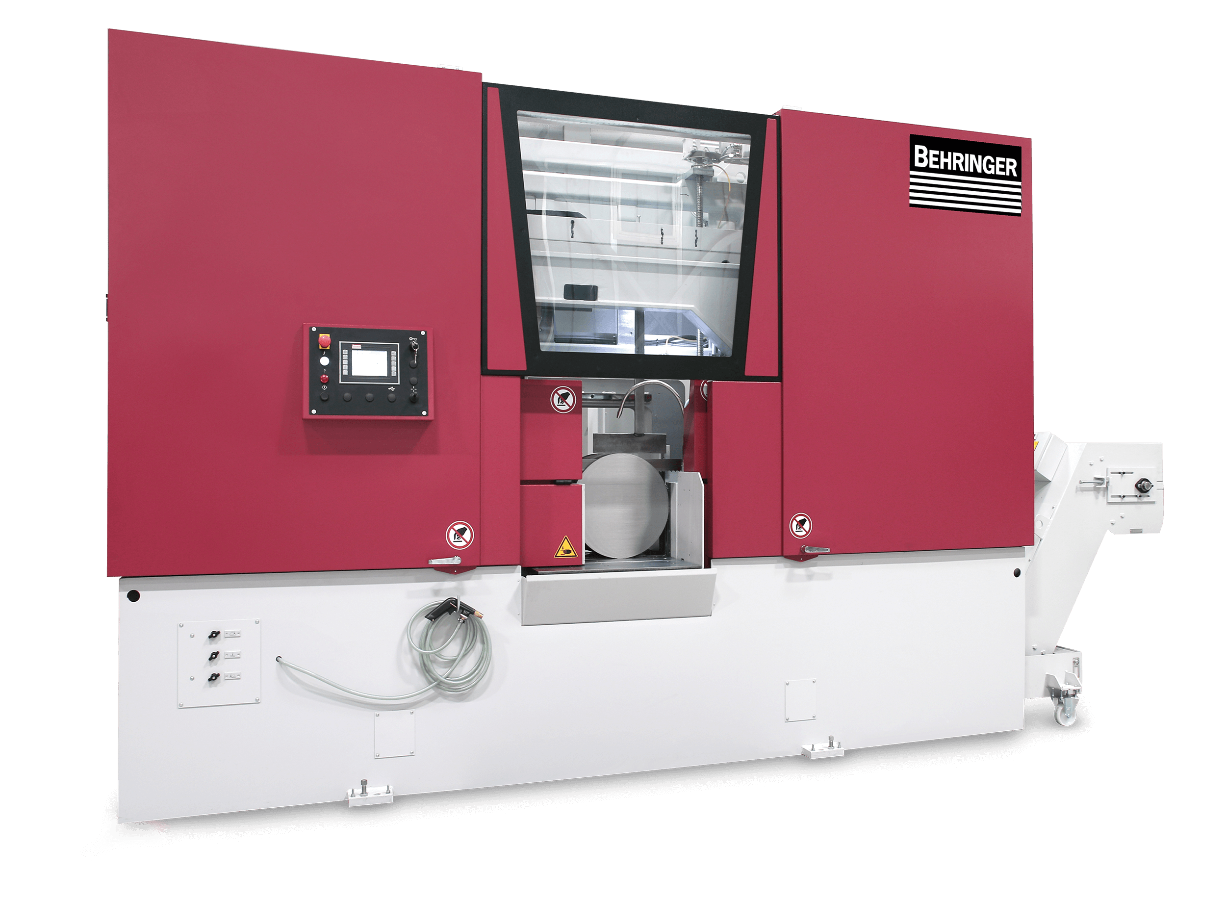 | 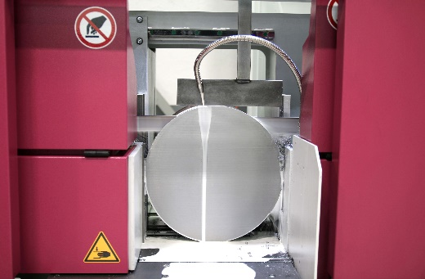
High-performance automatic bandsaw HBE560A Performance for demanding applications. | Highest cutting performance when sawing with bimetal and carbide saw blades.
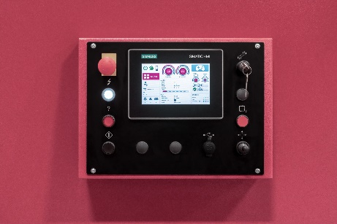
The new, intuitive control interface for Behringer bandsaws and circular saws from Behringer Eisele.

