EMO 2023 Hanover: Hall 3 / Booth E20
Efficient sawing of aluminium

The automatic circular saw VA-L 500 E offers maximum output and process reliability
With the VA-L 500 E, Behringer Eisele offers an automatic circular saw that is consistently designed for sawing aluminium and non-ferrous metals. Gentle material handling, high output, short remnant lengths and process-reliable chip disposal were key factors in the development of the VA-L series. The VA-L 500 E is the entry-level model in the series and covers a cutting range of up to 175 mm in diameter by using carbide-tipped saw blades up to 500 mm.
The high-performance aluminium circular saw scores with an unmatched high system throughput, both in solid material and in tubes and profiles with demanding cross-section geometry. The short remnant length of only 90 mm in automatic mode saves expensive material. Its feeding gripper with controlled zero edge provides gentle material handling and prevents damage to the material surface. For this purpose, the aluminium bars are lifted from the material support and moved away from the fixed jaw during positioning.

Excellent surface quality
A robust design with state-of-the-art drive technology for the feed axis and an extremely rigid saw spindle bearing ensure an optimal, low vibration cutting process. The VA-L 150 E can thus meet requirements in terms of surface finish of Rz < 8 µm and cut-off tolerances < 0.1 mm. The workpieces can therefore in many cases be passed on to further operations without post-processing.

Shorter non-productive times
The servo-driven saw feed defines a new performance class that achieves significantly higher cutting rates by creating a constant saw feed. When optimising the system throughput, reducing non-productive times must not be forgotten. The VA-L 500 E’s precise positioning of the saw head on the material and the fast positioning movements significantly minimise non-productive times. The pneumatic material clamping with short-stroke cylinders and the feeding gripper with travel speeds of up to 1,000 mm/s ensure fast material positioning. As a positive side effect, sustainable environmental management can be realised very easily by completely dispensing with machine hydraulics.

Maximum occupational safety
Occupational safety and ergonomics are focal points of the unique VA-L machine concept. The working area of the aluminium circular saw is completely enclosed as standard. The tight housing virtually eliminates the risk of injury from manual intervention during the sawing process and drastically reduces noise emissions. The produced aluminium chips and dusts are removed in a process-safe manner by connecting to an external extraction system. The enclosure can also be opened over a large area so that all important components are easily accessible for cleaning and maintenance work.

Photo Captions:
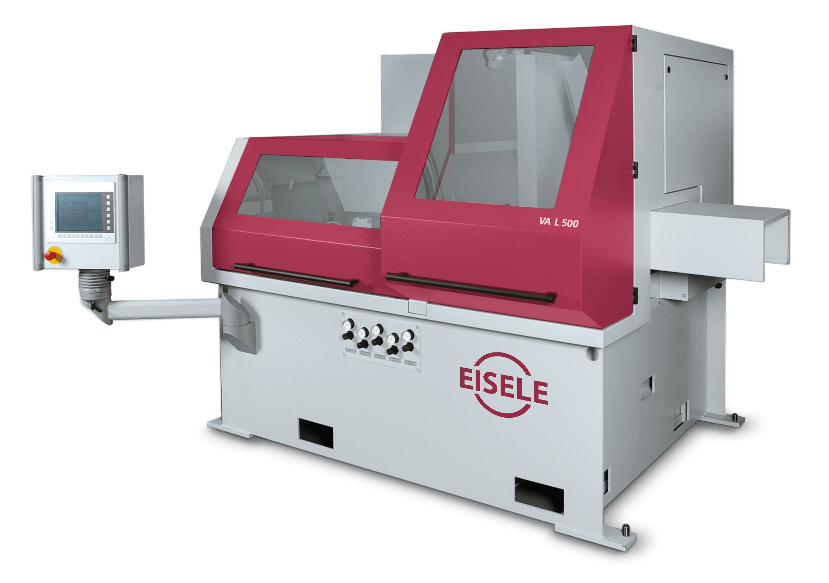 | 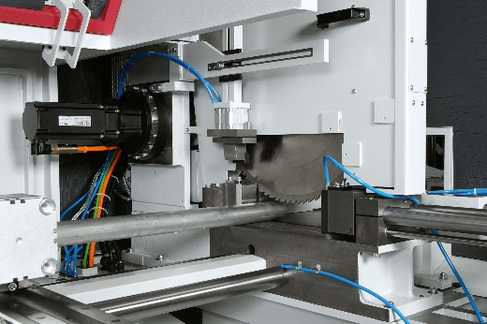
The VA-L 500 E is a specialist for mass cutting of aluminium and non-ferrous metals. | The servo rocker of the VA-L series provides significantly increased cutting performance by constant chip removal.

