EuroBLECH 2022 Hanover: Hall 12 / Booth F85

Automatic table bandsaw LPS-TA
Clever solution for automated sawing of metal plates and blocks
Flat steel bar is considered an important starting material for the processing industry. It offers a wide range of applications, for example in tool making, automotive industry or mechanical engineering. However, frequently changing dimensions and small batch sizes place high demands on procurement and logistics. Blanks from ingot and plate material offer significant advantages here, provided a suitable sawing solution is available.
The new, automatic table bandsaw LPS-TA from Behringer cuts plates and blocks up to 1,520 x 620 mm in size and 3 tons maximum weight fully automated. Flat steel bar of various thicknesses and special dimensions can thus be produced automatically in a single setup. Thanks to its sophisticated safety features, the table bandsaw is extremely compact and can be set up and operated even in confined spaces.

Quick setup – simple operation
With its movable material table, the table bandsaw can be conveniently loaded and unloaded by crane. Due to the sawing principle from the inside table to the outside, already sawn parts can be easily removed.
The automatic plate saw is controlled by an intuitive touch control that guides the user step by step through the programming. After entering the plate dimensions and clamping the material in the gripper, the saw sets itself up automatically.
High cutting precision and short cutting times
Its torsion-resistant design, the linear guided material table, the use of vibration-damping cast components and the band guides close to the material to be sawn ensure high cutting accuracy, smooth operation and long blade lives. The standard servo feed system with cutting pressure control optimally adapts the saw feed to the material to be sawn. The result is constant chip removal, higher overall cutting performance than with conventional systems, and reliable protection of the saw band against overload.
A special feature of the LPS-TA is the kerf channel extension, which allows the use of carbide blades. The cut-off is clamped after sawing through and the cutting channel is enlarged by the positioning unit before the saw band is retracted. Thus, tool steels, high-alloy stainless steels or nickel-based alloys can be effectively cut.

Reliable chip disposal
Powerful saw cuts generate large quantities of chips. Electric chip brushes arranged on both sides clean the saw band from adhering chips. To dispose them reliably, a large chip conveyor with integrated coolant tank is located underneath the saw unit, directly in the direction of chip flow. The conveyor can be moved out of the machine base for cleaning and maintenance work.

Image captions:
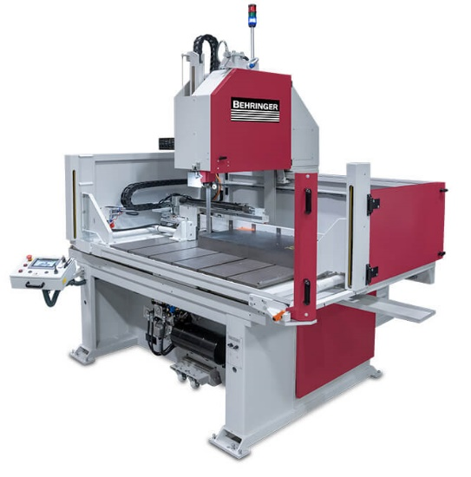 | 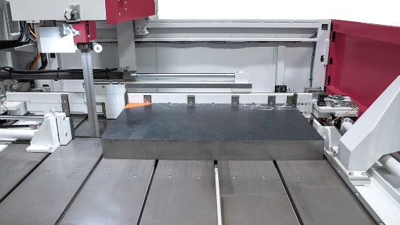
By using the LPS-TA automatic table bandsaw, advantages can be achieved in material purchasing. | The combination of NC-controlled positioning unit and intelligent control allows plates to be split in an automated manner.

